


Al Imam Mohammad Ibn Saud Islamic University
College of Computer and Information Sciences
Information Technology Department

CV-MindCare: Real-Time Computer Vision System for Mental Health Monitoring and Support

By:

Group#
Salman Abdullah Al-Sahli (444002924)
Ahmad Adnan Al Dahabi (444000293)

Supervised by:
Dr. Abdullah Almoqbil

Fall 2025

Abstract

Mental health disorders, such as anxiety and depression, are rising globally, yet many individuals lack access to timely support due to stigma, cost, or limited resources. Traditional methods like surveys or wearable devices are intrusive, lack real-time insights, or fail to capture nuanced behavioral cues. This proposal outlines the development of CV-MindCare, a privacy-aware system that leverages computer vision (CV) and artificial intelligence (AI) to monitor mental health indicators in real time. The system analyzes facial expressions (e.g., sadness, stress), eye movements (e.g., fatigue), and posture (e.g., slouching) using deep learning models like FER-2013 and MediaPipe. When distress signals are detected, the system provides personalized interventions such as mindfulness exercises, breathing prompts, or escalation to professionals. By combining non-invasive behavioral analysis with clinically validated mental health metrics, CV-MindCare empowers users to manage their well-being proactively, reduces reliance on subjective self-reports, and promotes accessible mental health support.

Keywords:
Mental health monitoring, computer vision, artificial intelligence, emotion detection, facial expression recognition, eye movement tracking, posture analysis, real-time intervention, non-invasive sensing, stress detection, edge AI, privacy-aware systems.

Abstract (Arabic)
تزداد مشاكل الصحة النفسية مثل القلق والاكتئاب في جميع أنحاء العالم. ولكن كثير من الناس لا يحصلون على المساعدة التي يحتاجونها في الوقت المناسب، وذلك بسبب الخجل من طلب المساعدة، أو ارتفاع التكاليف، أو قلة الأطباء المختصين.
الطرق التقليدية للكشف عن الحالة النفسية مثل الاستبيانات أو الأجهزة القابلة للارتداء ليست دائمًا فعّالة. فهي غالبًا ما تكون مزعجة، ولا تعطي نتائج في الوقت الفعلي، ولا تستطيع فهم الإشارات الصغيرة التي قد تدل على أن الشخص يعاني من التوتر أو الحزن.
يقترح هذا المشروع تصميم نظام ذكي اسمه CV-MindCare. هذا النظام يحافظ على خصوصية المستخدم ويستخدم كاميرا وذكاء صناعي لمراقبة علامات التوتر أو الحزن بشكل مباشر وفوري.
يقوم النظام بتحليل:
- (تعبيرات الوجه( مثل الحزن أو القلق
- (حركات العين) مثل التعب أو كثرة الرمش
- (وضعية الجسم( مثل الانحناء عند الجلوس
- ويستخدم في ذلك تقنيات متقدمة مثل FER-2013 و MediaPipe ، والتي تساعد في فهم مشاعر الإنسان من مظهره الخارجي.
عندما يلاحظ النظام أن المستخدم قد يكون متوترًا أو حزينًا، فإنه يقترح عليه أشياء مفيدة مثل:
- تمارين تنفس مريحة
- جلسات تأمل قصيرة
- أو إرسال تنبيه لطلب المساعدة من مختص نفسي (إذا لزم الأمر)
هذا النظام يساعد الناس على الاهتمام بأنفسهم نفسيًا بطريقة سهلة، وبدون الحاجة للذهاب إلى الطبيب في كل مرة. كما أنه لا يسجل الفيديو أو يشارك البيانات، مما يجعله آمن ويحافظ على الخصوصية.

List of Abbreviations

[List the abbreviations you have used in your project if there are any and what are they stands for, in alphabetical order]

Samples:
Abbreviation | Full Form | Why It Matters
VOC | Volatile Organic Compounds | Central to air quality monitoring; many readers won’t know what VOCs are.
TFLite | TensorFlow Lite | You’re using lightweight AI models on the Pi — this is critical to explain for your AI/ML processing.
FFT | Fast Fourier Transform | Essential for noise analysis from microphone input — technical but relevant.
I²C | Inter-Integrated Circuit | Used to connect most sensors (e.g., air quality, temperature); important to clarify.
DSI | Display Serial Interface | Key if you're using a touchscreen via the Pi’s DSI port; many confuse it with HDMI.

Table of Contents
Abstract ii
Abstract (Arabic) iii
List of Abbreviations iv
Table of Contents v
List of Figures vii
List of Tables viii
1 Introduction 2
1.1 Introduction 2
1.2 Problem Definition 2
1.3 Local Impact 3
1.4 Global Impact 3
1.5 Project Scope 4
1.6 Aims and Objectives 5
1.7 Alternative Solutions 6
1.8 Method / Approach 7
1.9 Project Requirements 8
1.10 Project Timeline 8
1.11 Report Structure 10
1.12 Summary 11
2 Literature Review 13
2.1 Introduction. 13
2.2 Background 13
2.3 Related Work 15
2.4 Summary 16
3 System Analysis and Design 18
3.1 Introduction 18
3.2 System Perspective 18
3.3 Requirements Elicitation Techniques 19
3.4 System Requirement 20
3.5 Use Cases 21
3.6 System Design 26
3.7 Summary 26
3.8 References 27
Appendix 29
A. Miscellaneous 30

List of Figures
Figure1: Agile Methodology.......................................................................................... 7 Figure2: Timeline........................................................................................................... 9 Figure3: Flowchart........................................................................................................ 14
Figure4: Sequence diagram for use case 1 ................................................................... 24 Figure5: Sequence diagram for use case 2 ................................................................... 24 Figure6: Sequence diagram for use case 3 ................................................................... 25
Figure7: Question 1 in the survey................................................................................. 31
Figure8: Question 2 in the survey................................................................................. 31
Figure9: Question 3 in the survey................................................................................. 31
Figure10: Question 4 in the survey............................................................................... 32
Figure11: Question 5 in the survey............................................................................... 32
Figure12: Question 6 in the survey............................................................................... 32
Figure13: Question 7 in the survey............................................................................... 33
Figure14: Question 8 in the survey............................................................................... 33
Figure15: Question 9 in the survey............................................................................... 33
Figure16: Question 4 in the survey............................................................................... 34
Figure17: Question 5 in the survey............................................................................... 34

List of Tables
Table 1: Team Qualifications ............................................................................................10 Table 2: Use case 1........................................................................................................... 21 Table 3: Use case 2........................................................................................................... 22
Table 4: Use case 3 .......................................................................................................... 23

Chapter One: Introduction

Introduction

Introduction
In recent years, the integration of artificial intelligence (AI) and embedded systems has opened new possibilities for smart, real-time monitoring in both personal and public environments. This project introduces a compact, intelligent system based on the Raspberry Pi 5 that combines face recognition, emotion detection, air quality monitoring, and noise detection into one seamless solution.
The primary objective of the system is to enhance awareness of both mental well-being and environmental conditions. Using computer vision, the device can detect facial expressions and analyze emotional states such as happiness or anxiety. Simultaneously, it measures air quality using sensors that detect VOCs (Volatile Organic Compounds), particulate matter, and other atmospheric indicators. The system also includes a microphone to monitor ambient noise levels, making it ideal for environments such as schools, clinics, workplaces, or smart homes.
By processing data locally on the Raspberry Pi and displaying insights through a built-in touchscreen, the system ensures real-time feedback while maintaining user privacy. Additionally, integration with DeepSeek AI allows for more advanced analytics when needed.
This project aims to create a practical, low-cost, and privacy-conscious solution to support mental health, environmental safety, and personal comfort—offering a step forward in the development of accessible, AI-powered smart monitoring systems.

Problem Definition
An ideal system for mental well-being and environmental health monitoring would enable real-time, privacy-conscious detection of emotional states (e.g., anxiety, stress) and environmental risks (e.g., air pollution, noise). However, traditional mental health assessments—such as surveys or wearable devices—are subjective, lack contextual awareness of environmental factors, and fail to capture nuanced behavioral cues like facial micro-expressions or posture [1], [2]. Existing AI-driven solutions often rely on cloud processing, raising privacy concerns, while edge devices like the Raspberry Pi struggle with computationally intensive tasks like real-time multi-sensor fusion [3], [5]. Environmental sensors for air quality (PM2.5, VOCs) or noise levels are rarely integrated with behavioral health metrics, missing critical correlations between external stressors and internal states [4], [6]. These gaps delay interventions, leaving individuals in schools, workplaces, or clinics vulnerable to untreated mental health conditions or prolonged exposure to harmful environments.

Local Impact
- Enhanced Mental Health Support:
  - Enables real-time detection of emotional states (e.g., anxiety, stress) in schools, workplaces, or clinics, empowering individuals to seek timely interventions like mindfulness exercises or breathing prompts.
  - Reduces stigma by integrating mental health monitoring into daily environments through non-invasive technology.
- Immediate Environmental Awareness:
  - Provides actionable insights on air quality (PM2.5, VOCs) and noise levels, allowing households, schools, or offices to address risks (e.g., improving ventilation, reducing noise exposure).
- Affordable Accessibility:
  - Raspberry Pi-based design lowers costs, making the system accessible to underserved communities, rural areas, or institutions with limited healthcare budgets.
- Privacy Preservation:
  - Local data processing ensures sensitive health and environmental data remain on-device, fostering trust in communities wary of cloud-based surveillance.
- Community-Driven Solutions:
  - Aggregated data can inform local policymakers to implement targeted regulations (e.g., noise reduction zones, air quality standards).

Global Impact
- Scalable Mental Health Tools:
  - Addresses the rising global mental health crisis by offering a replicable, low-cost system for early detection of conditions like anxiety and depression.
- Climate-Health Correlation:
  - Combines environmental and behavioral data to study how air pollution or noise impacts mental well-being globally, supporting climate resilience efforts.
- Reduced Healthcare Burden:
  - Proactive monitoring could prevent severe mental health episodes, lowering long-term healthcare costs and easing strain on overburdened systems.
- Ethical AI Advocacy:
  - Demonstrates the viability of privacy-preserving, edge-based AI, countering reliance on centralized cloud systems that risk data exploitation.
- Alignment with Global Goals:
  - Directly supports UN Sustainable Development Goals (SDGs), including SDG 3 (Health), SDG 11 (Sustainable Cities), and SDG 13 (Climate Action).
- Empowerment of Marginalized Groups:
  - Democratizes access to mental health and environmental safety tools for vulnerable populations (e.g., low-income communities, disaster-affected regions).

Project Scope
The Smart Monitoring System aims to create a Raspberry Pi-based edge device capable of real-time emotion recognition, air quality analysis, and noise level detection. To ensure a focused and manageable development cycle, the project scope includes:
Hardware Integration
• Configuring environmental sensors for air quality (PM2.5, VOCs) and a microphone for noise level detection.
• Setting up a camera module for facial expression analysis and integrating all sensors with the Raspberry Pi 5.

AI Processing and Analytics
• Implementing emotion recognition models (e.g., CNNs) using facial landmark data to classify emotional states like happiness, stress, or anxiety.
• Developing lightweight, on-device processing pipelines to correlate emotional states with air quality and noise metrics.

User Interface and Feedback System
• Creating a local touchscreen dashboard to display real-time environmental conditions and emotional state feedback.
• Including alert mechanisms (e.g., color-coded indicators, wellness prompts) for abnormal readings or stress detection.

Testing and Validation
• Conducting usability tests in simulated environments like classrooms or clinics to evaluate system accuracy and responsiveness.
• Gathering user and expert feedback on interface design, data relevance, and privacy expectations to guide future iterations.

Out of scope are advanced emotional analytics (e.g., body posture or tone of voice), long-term behavioral tracking, and cloud-based data aggregation. Future phases may explore these aspects once the core system proves reliable in real-time local operation.

Aims and Objectives
- Integrate Multimodal Sensors
  - Set up and calibrate environmental sensors (for PM2.5, VOCs, temperature, and noise) and a camera for facial expression capture on the Raspberry Pi 5.
- Develop Emotion Recognition Module
  - Implement facial expression analysis using computer vision and machine learning to detect emotional states such as stress, anxiety, or happiness in real-time.
- Enable Real-Time Data Processing
  - Optimize data pipelines to ensure all sensor inputs are processed locally on the Raspberry Pi, avoiding reliance on cloud computing and preserving user privacy.
- Design a User-Friendly Interface
  - Build a touchscreen dashboard that displays emotional states and environmental quality insights, along with visual alerts and recommendations for action.
- Validate Accuracy and Usability
  - Conduct controlled tests and user studies to evaluate the system’s responsiveness, accuracy, and acceptance across different use-case scenarios.
- Demonstrate Low-Cost, Scalable Deployment
  - Ensure the system remains affordable, easy to assemble, and adaptable for use in underserved or resource-constrained communities.

Alternative Solutions

Solution | Description | Cost | Benefits
Wearable Health Trackers | Devices like smartwatches that monitor stress via heart rate and physical activity | Medium to High | Non-intrusive, continuous monitoring, user-friendly interface, readily available in the market
Cloud-based AI Monitoring Systems | Systems that use cloud computing to analyze facial expressions and environmental data from remote devices | High | Powerful processing, scalable analytics, access to large datasets
Standalone Air Quality Monitors | Devices focused only on environmental data (e.g., VOC, PM2.5, CO2 levels) | Low to Medium | Accurate environmental insights, easy to install and use
Mobile Apps for Mental Health | Smartphone apps using questionnaires or self-reporting to track mood and stress | Low | Accessible, scalable, often free or low-cost, supports early self-intervention
Human-Based Monitoring (e.g., counselors + manual tools) | Use of trained professionals and environmental instruments for observation and evaluation | High (labor cost) | Personalized feedback, trusted in institutional settings
IoT Smart Home Devices (e.g., Alexa, Nest) | Home automation systems with some environmental and voice-monitoring capabilities | Medium to High | Integrates into smart environments, user convenience, partial support for ambient monitoring

Conclusion of Alternative Solutions:

Most existing solutions address either emotional well-being or environmental monitoring, but not both. Wearables and apps are affordable but lack environmental context.
Cloud-based systems offer power but compromise privacy and require internet access.
Standalone monitors don’t capture user emotion.
Human-based methods are accurate but not scalable or real-time.
Smart home devices are convenient but limited in behavioral insights.
The proposed Raspberry Pi system uniquely combines all features in a private, low-cost, and real-time solution.

Method / Approach

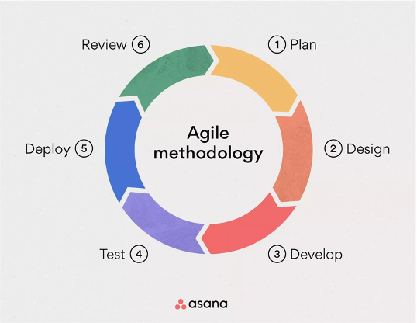
First In this project, the Agile methodology will be used because it is iterative, flexible, and reduces risks while allowing changes and adaptations throughout the development process. The methodology consists of six phases as shown in Figure 1: Agile model. These stages are developed to achieve the goal of having a well-planned and sequentially managed development process. The stages include:
Figure 1: agile methodology
- Planning
Define requirements (e.g., privacy, real-time performance) and select tools (Python, OpenCV, PyTorch).

- Design:
Create system architecture (CV module, dashboard) and select datasets
(e.g. CK+, DAiSEE).

- Develop:
A. Build modules incrementally: • CV Module:
Train emotion/posture detection models.
B. Intervention Engine: Develop rule-based alerts
(e.g., "Take a break after 10 minutes of detected stress").

4. Test:
Validate accuracy (F1-score) and usability with pilot users.

5. Deploy:
Launch a web/mobile app with local data processing.

6. Review:
Gather feedback to refine interventions and UI.
for the end user.

Project Requirements

Software Requirements:
Python, OpenCV, TensorFlow/PyTorch (CV models).
Flask/Django (backend), React/Flutter (frontend).
SQLite for local data storage.
Hardware Requirements:
Webcam/smartphone camera for data capture.
Edge devices (e.g., Raspberry Pi) for local processing.

Project Timeline
To make sure the project stays on track and gets done within the set timeframe, all the tasks have been broken down into clear, manageable steps. A Gantt Chart was used to keep track of everything because it's easy to read and really helps with organizing the schedule. It makes planning simpler and helps us see what needs to be done and when. using the chart also helps identify any overlaps or delays early on, so adjustments can be made if needed. It’s a great way to visualize progress and stay organized throughout the process. Overall, it keeps the whole team on the same page and focuses on the end goal.
Figure 2 shows the timeline of the project and how long each task is expected to take.

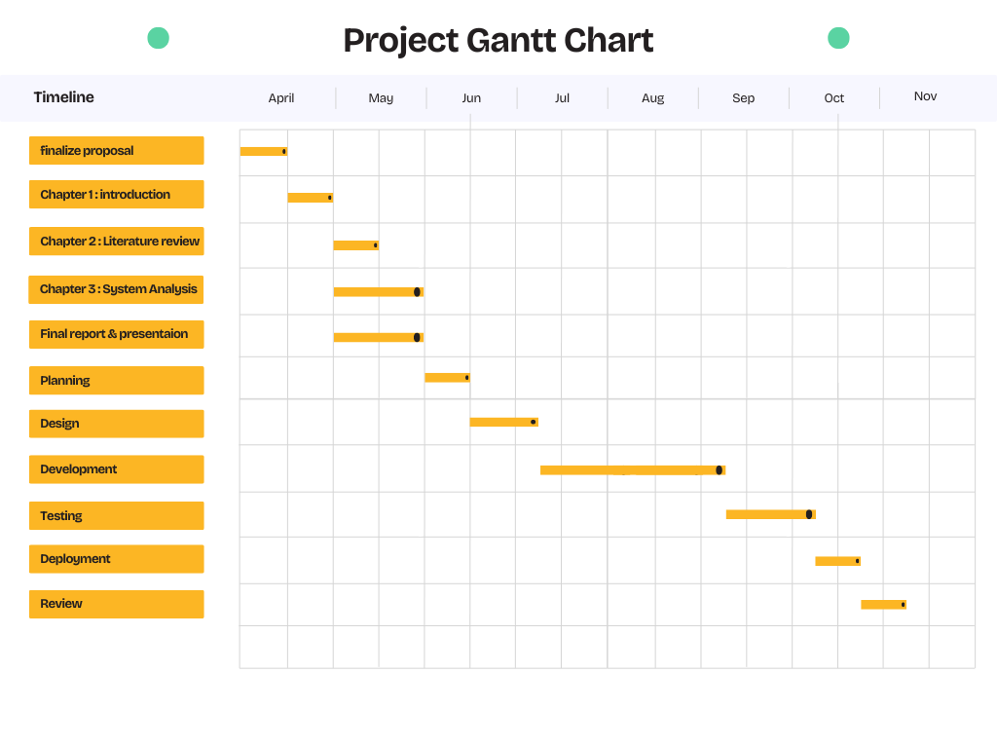
Figure 2: Project Timeline
1.11 Team Qualifications
The team responsibilities are distributed across various tasks, ensuring smooth and efficient project execution. As shown in Table 1: Team Member’s Responsibilities, each task phase is outlined with its respective roles and responsibilities, which are collectively undertaken by all team members.

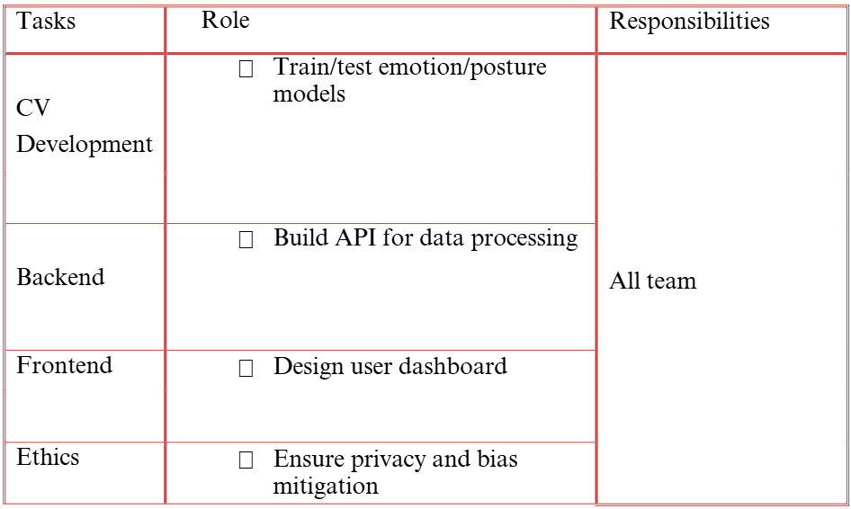
Table1: Team Qualifications & Responsibilities

Report Structure
The Graduation Project Report is organized into the following chapters, each serving a specific purpose
- Chapter 1: Introduction - Provides the background of the problem, discusses related work, and gives an overview of the project and report structure.
- Chapter 2: Literature Review - Summarizes existing methodologies and technologies relevant to the problem and highlights the gaps that the proposed solution aims to address.
- Chapter 3: System Analysis and Design - Outlines the system’s requirements, design, and architecture, including detailed diagrams and use cases.

Summary
The proposed intelligent monitoring system tackles the growing need for real-time, privacy-preserving tools that assess both mental well-being and environmental conditions. Traditional approaches—such as manual mental health assessments or isolated environmental sensors—often fail to capture the interconnected effects of external stressors (like air pollution or noise) on emotional health. Moreover, many AI-driven solutions rely on cloud-based processing, raising privacy concerns and limiting accessibility in sensitive or offline environments.
Existing systems tend to focus on either emotional monitoring or environmental sensing, rarely combining the two. This separation overlooks the opportunity to better understand how environmental factors contribute to stress, anxiety, or other emotional states. Additionally, cloud-based models often require stable internet and can introduce data security risks.
This project introduces an edge-based, compact system built on Raspberry Pi 5, integrating facial emotion recognition, air quality sensors, and noise detection into a single device. Data is processed locally and displayed via a built-in touchscreen, ensuring user privacy and real-time feedback. Compared to conventional tools, this design enhances user awareness, promotes proactive wellness, and makes advanced monitoring accessible to schools, clinics, workplaces, and homes.
In the next chapter, the Literature Review will examine related work and existing technologies, highlighting their limitations and establishing the value this project brings to advancing holistic, AI-powered monitoring systems.

Chapter Two: Literature Review

Literature Review

Introduction.
As artificial intelligence becomes more integrated into smart environments, there is a growing interest in systems that monitor both emotional states and environmental conditions. Combining emotion recognition with environmental sensing can offer a deeper contextual understanding in applications such as healthcare, smart homes, education, and public safety. This chapter reviews the existing literature related to face recognition, emotion analysis, air quality monitoring, noise detection, and embedded system integration using Raspberry Pi. It identifies current gaps and outlines the significance of the proposed system.

Background

The intersection of AI and IoT has enabled the creation of compact yet powerful systems capable of sensing, processing, and responding to environmental and behavioral inputs in real-time. Your project combines three major domains :
- Face Recognition and Emotion Detection
Face recognition using computer vision is widely used in access control, security, and human-computer interaction. Emotion detection goes further by analyzing facial expressions to infer psychological states such as happiness, sadness, or anxiety. Techniques involve CNNs and datasets like FER-2013.
- Air Quality Monitoring
Environmental sensors such as MQ135, BME680, and PMS5003 are capable of detecting VOCs, CO₂, PM2.5, and temperature/humidity levels. These are crucial for health-focused smart systems.

- Noise Detection and Sound Classification
Microphones connected via USB, I²S, or analog+ADC interfaces can be used to monitor ambient sound levels. Sound data can be analyzed using FFT or machine learning models to detect specific noise events or gauge loudness over time.
- Embedded AI on Raspberry Pi
Raspberry Pi 5 enables local execution of lightweight AI models using TensorFlow Lite, OpenCV, or DeepSeek AI APIs. It is suitable for edge AI due to its improved processing power and GPIO expandability.
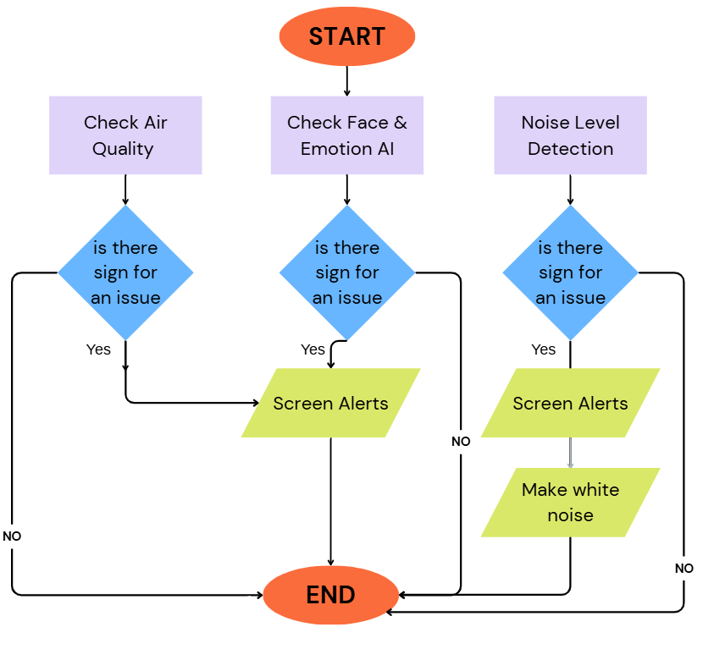
Figure3: Flow Chart

Related Work
Facial Emotion Detection on Edge Devices
- Sani et al. (2022) implemented a facial emotion recognition model using MobileNetV2 + FER2013 on Raspberry Pi 4. Their system achieved real-time performance (6–8 FPS) for 5-class emotion detection using TFLite.
- Limitation: No integration with environmental sensors; focused only on facial expressions.
Air Quality Monitoring with Raspberry Pi
- Kumar and Sharma (2021) developed an indoor air monitoring system using MQ135 and PMS5003, logging data to a cloud dashboard.
- Limitation: Lacked any user feedback or AI-based interpretation.
Noise Detection via Microphone Arrays
- Zhang et al. (2020) designed a noise detection system using I²S MEMS microphones and FFT on ESP32.
- Limitation: Audio processing was limited to raw threshold detection, with no contextual AI analysis.
Multi-modal Smart Monitoring Systems
- Ahmed et al. (2023) proposed a multi-sensor smart home prototype using a Raspberry Pi, integrating environmental sensors and facial recognition via OpenCV.
- Limitation: Emotion recognition was not included; no use of AI accelerators or DeepSeek AI.

Summary
This chapter explores the convergence of AI and embedded systems in the context of emotion and environmental monitoring. It begins by highlighting the importance of integrating facial expression analysis with air quality and noise sensing to provide contextual insights in settings like healthcare, education, and smart homes. The background section introduces the core technologies used in the project, including facial recognition with CNNs, environmental sensors for VOCs and PM2.5, noise monitoring through microphones, and the application of edge AI on Raspberry Pi 5.
The related work review presents several prior implementations: emotion recognition models on Raspberry Pi, standalone air quality systems, and basic noise detection solutions. While each contributes valuable insights, most suffer from limited scope—focusing on only one data type, lacking AI-driven feedback, or not ensuring real-time performance. These gaps underline the uniqueness of the proposed system, which integrates all components into a unified, privacy-conscious platform.

Chapter Three: System Analysis and Design

System Analysis and Design

Introduction
This chapter outlines the analytical and design framework for the proposed intelligent monitoring system. It provides an overview of how the system fits into its environment, the methods used to gather user and technical requirements, and the key functional and non-functional specifications needed for successful implementation. The aim is to ensure the system aligns with user expectations, technical feasibility, and broader project goals while maintaining high standards of performance, usability, and data privacy.
Scope:
The scope of this system includes the integration of facial recognition, emotion detection, air quality monitoring, and noise sensing into a single, Raspberry Pi-based device. The system will provide real-time feedback via a local display, with all data processed on-device to preserve privacy. It is intended for use in indoor environments such as classrooms, clinics, homes, and workplaces. Out of scope are mobile app integration, cloud-based emotion analytics beyond optional DeepSeek AI support, and biometric authentication features. Future development may extend to these areas once the core system proves reliable.
.

System Perspective
The proposed system is an edge-based smart monitoring device designed to operate autonomously in environments such as schools, clinics, offices, and homes. It integrates multiple subsystems—facial recognition, emotion detection, air quality monitoring, and noise level sensing—into a single platform based on Raspberry Pi 5. The system functions as a standalone embedded solution, using local processing to ensure privacy and real-time feedback, while offering optional cloud connectivity (e.g., through DeepSeek AI) for advanced analytics.
The system architecture follows a modular design, allowing individual components (e.g., camera, sensors, display) to be independently tested, upgraded, or replaced. This design supports scalability, maintenance, and integration with other smart devices if needed.

Requirements Elicitation Techniques
To ensure accurate and user-driven design, several requirements elicitation techniques were used:
- Interviews: Conducted with teachers, healthcare workers, and IT specialists to understand practical expectations from real-time monitoring tools.
- Surveys: Distributed among potential users to gather insights on preferred features, usability expectations, and privacy concerns.
- Observation: Environments like classrooms and clinics were observed to assess common environmental conditions and potential stressors.
- Document Review: Technical documentation from previous systems and research papers helped benchmark system features and avoid known limitations.

System Requirement
3.4.1 Functional Requirements
- The system shall capture real-time facial images and detect emotional states.
- The system shall detect levels of air pollutants (VOC, CO₂, PM2.5).
- The system shall measure noise levels and identify abnormal spikes.
- The system shall display data and alerts on a local screen.
- The system shall trigger alerts when air or noise thresholds are exceeded.
- shall allow for updating or training new gestures in future versions.

    - Non-Functional Requirements
- Performance: Must detect face and classify emotion within 300 ms.
- Accuracy: Emotion recognition ≥ 85%, air quality readings ±5%.
- Usability: Touch UI with real-time data display.
- Privacy: All processing done locally; no camera feed stored or sent to the cloud.
- Power Efficiency: Optimized for 24/7 operation on USB-C power.
- calability: Easy to integrate new sensors or external APIs.

3.5 Use Cases

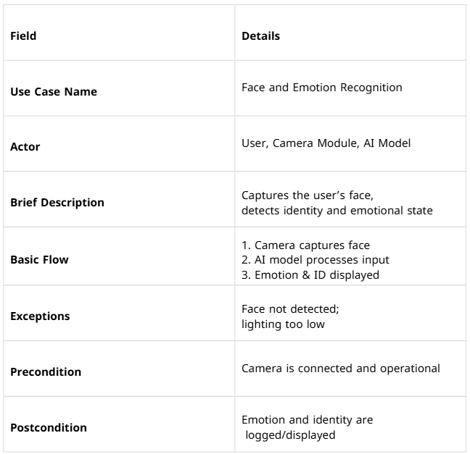
Table2: use case 1

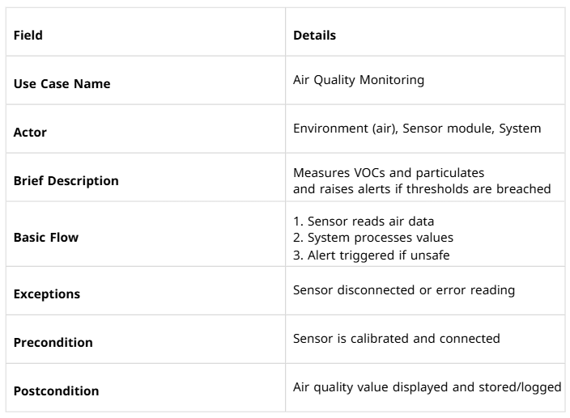 Table3: use case 2

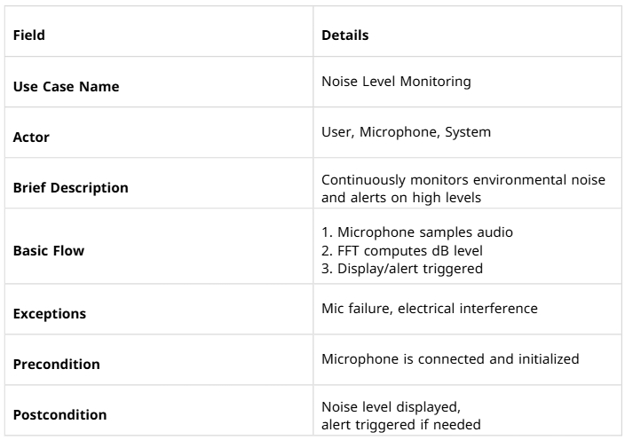Table4: use case 3

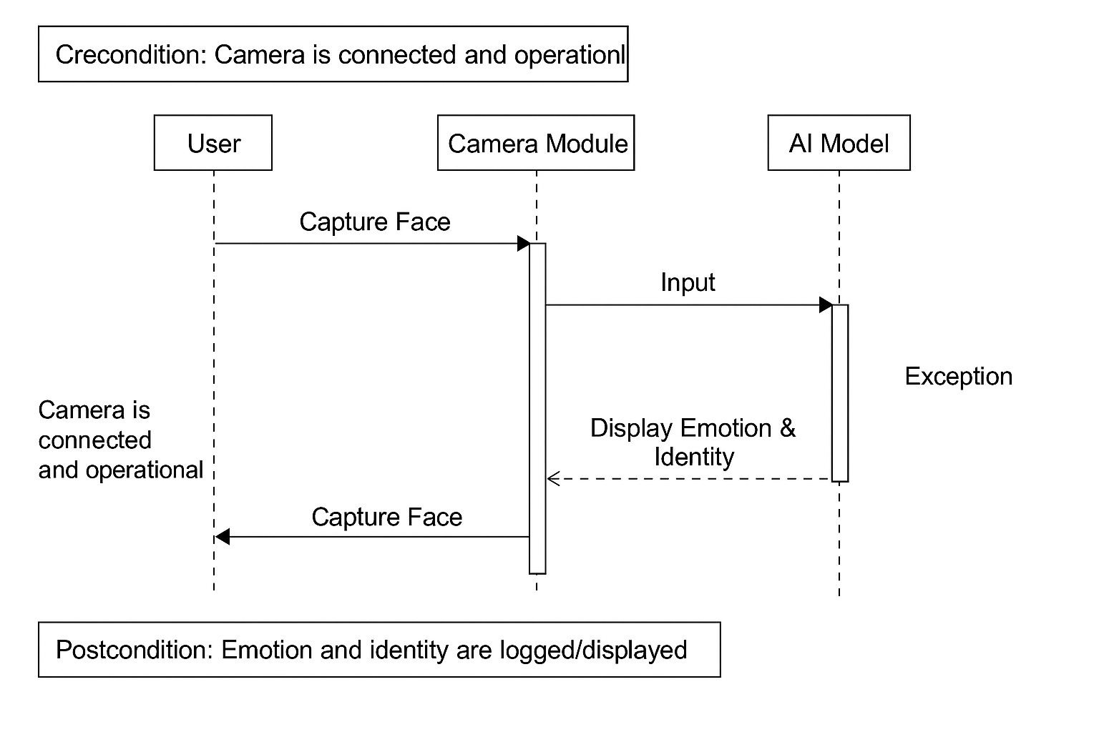 Figure4: Sequence diagram for use case 1

Figure5: Sequence diagram for use case 2

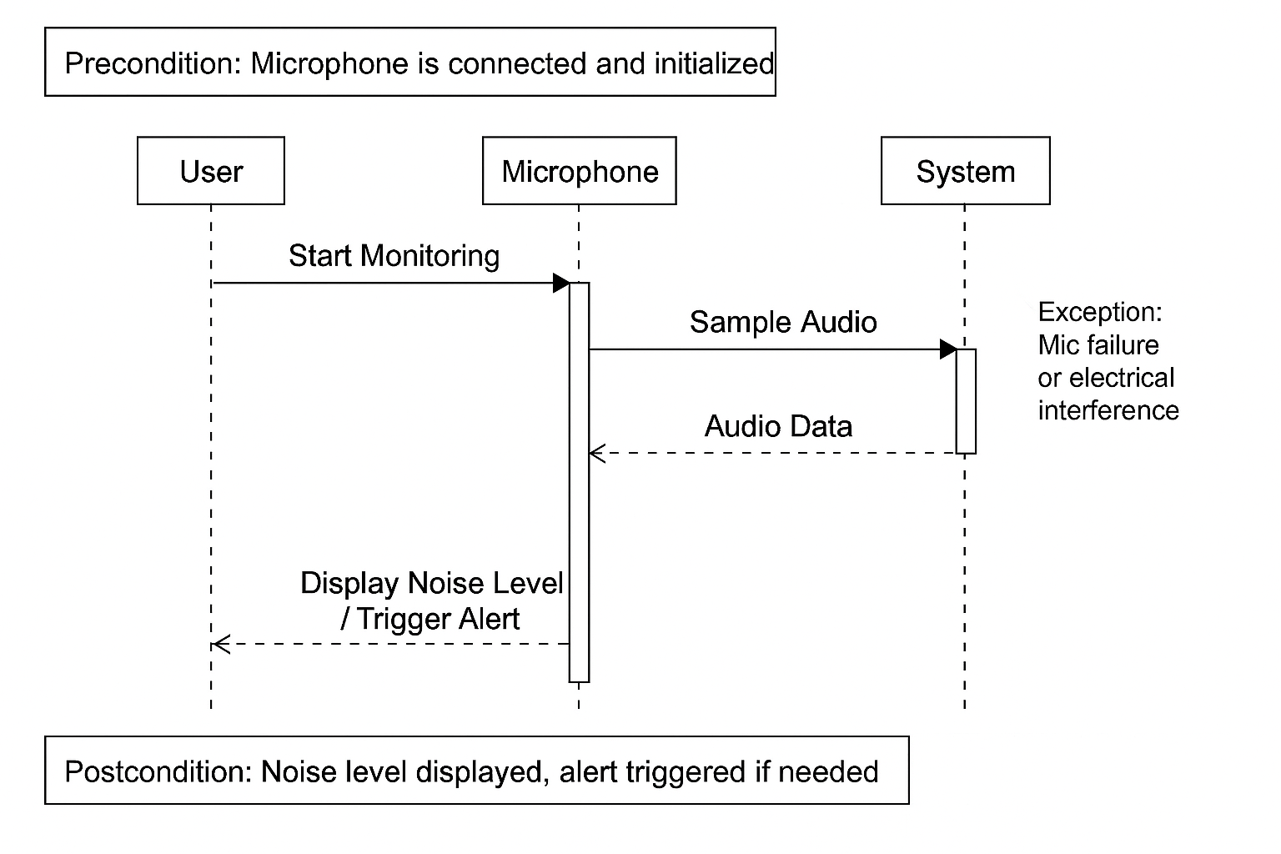
Figure6: Sequence diagram for use case 3

3.6 System Design
The system design of the proposed smart monitoring solution follows a modular and layered approach, ensuring scalability, efficiency, and real-time performance. The architecture integrates multiple sensor modules—including a camera, gas sensor, and microphone—connected to a Raspberry Pi, which acts as the central processing unit. Each module operates independently but contributes data to a unified decision-making system. The camera module captures facial images for identity and emotion recognition using a lightweight AI model processed locally. The air quality sensors continuously monitor VOCs and particulate levels, while the microphone detects ambient noise levels using FFT algorithms. A real-time processing pipeline manages data acquisition, analysis, and visualization, with thresholds triggering alerts or logging events. The system also includes a web-based dashboard for remote access to logs and alerts. This design ensures flexibility and supports edge AI computation, enabling offline operation, improved privacy, and faster response times in smart environments.

Summary
This chapter outlines the foundational planning and design principles guiding the development of the smart monitoring system. It begins with a system perspective, presenting the project as a modular edge-based solution combining emotion detection and environmental monitoring. Various requirements elicitation techniques—such as interviews, observation, and document analysis—were employed to gather accurate functional and non-functional requirements. Key functional requirements include real-time facial emotion recognition, air quality assessment, and noise detection, while non-functional requirements focus on privacy, low power consumption, and usability. The chapter also defines the system scope, ensuring alignment with user needs and technical feasibility. Overall, this analysis supports the creation of a reliable, responsive, and privacy-aware system suitable for healthcare, education, and smart living environments.

3.8 References

[1] V. Patel et al., “The Lancet Commission on global mental health and sustainable development,” The Lancet, vol. 392, no. 10157, pp. 1553–1598, Oct. 2018.
[2] R. Sioni and L. Chittaro, “Wearables and mental health: A systematic review,” JMIR mHealth and uHealth, vol. 9, no. 6, Jun. 2021.
[3] A. Esteva et al., “Privacy-preserving AI in healthcare: Challenges and opportunities,” Nature Digital Medicine, vol. 4, no. 1, pp. 1–5, Mar. 2021.
[4] H. Li et al., “Air pollution and cognitive decline: A systematic review,” Environmental Research, vol. 185, Jun. 2020.
[5] A. Dementyev et al., “Edge computing for real-time embedded AI,” ACM Transactions on Embedded Computing Systems, vol. 17, no. 4, pp. 1–25, Jul. 2018.
[6] World Health Organization, “Environmental noise guidelines for the European Region,” WHO, 2018. [Online]. Available: https://www.who.int/publications/i/item/9789289053563

Appendix

Miscellaneous

[Includes any further data (for example: interview form, questionnaire form, Interview
answers, questionnaire responses, remaining figures of data analysis …etc.)]

Questionnaires:
Survey Structure
1. General Awareness
Questions assessed whether participants had heard of Raspberry Pi, understood face recognition, and cared about environmental monitoring.
2. Feature Relevance & Interest
Participants were asked which features (emotion detection, air alerts, noise monitoring, etc.) they found most useful and where they'd install such a device.
3. User Acceptability
Questions covered comfort with camera-based emotion detection and preferences for offline vs. cloud processing (for privacy).
4. Demographic Information
Age, gender, educational background, technical familiarity (especially with AI and embedded systems).

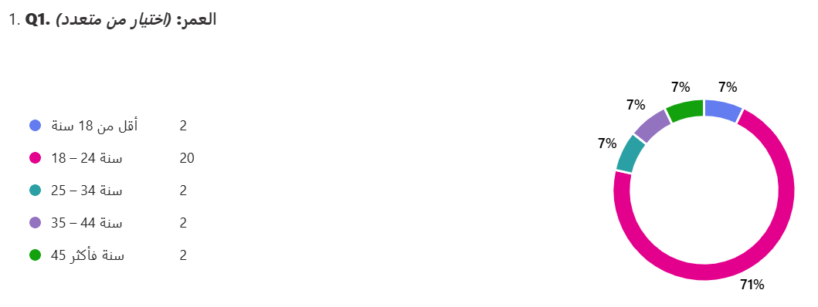 Figure7: Question 1 in the survey
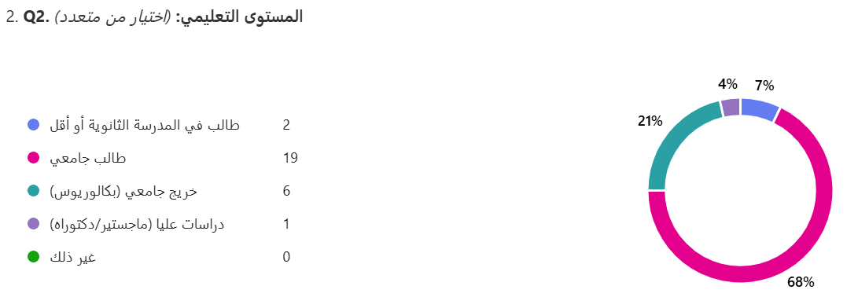 Figure8: Question 2 in the survey
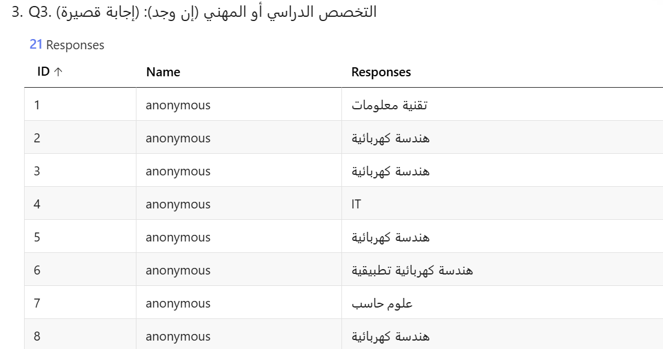
Figure9: Question 3 in the survey

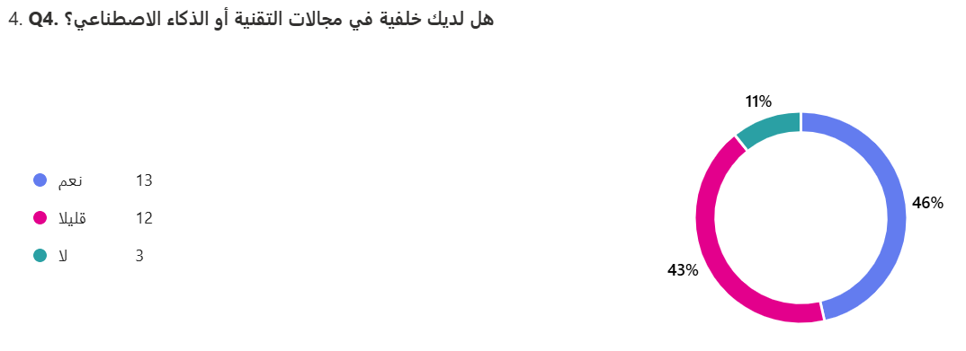 Figure10: Question 4 in the survey

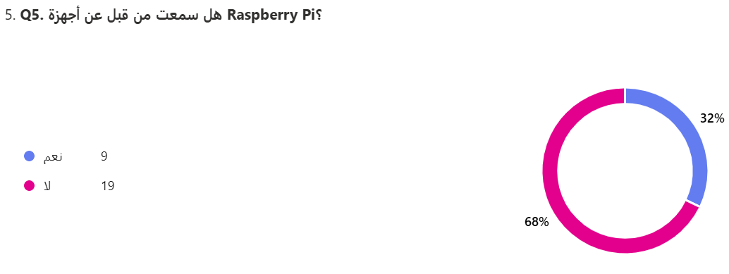
Figure11: Question 5 in the survey
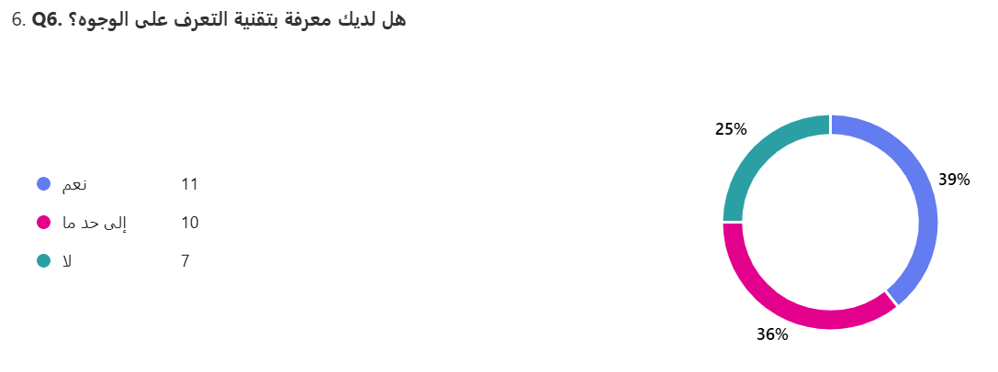
Figure12: Question 6 in the survey

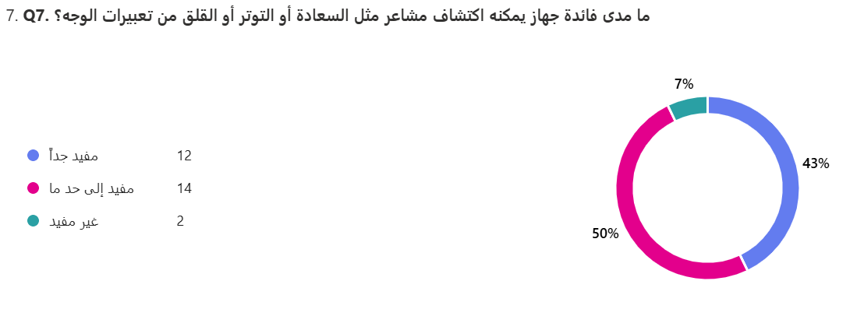 Figure13: Question 7 in the survey
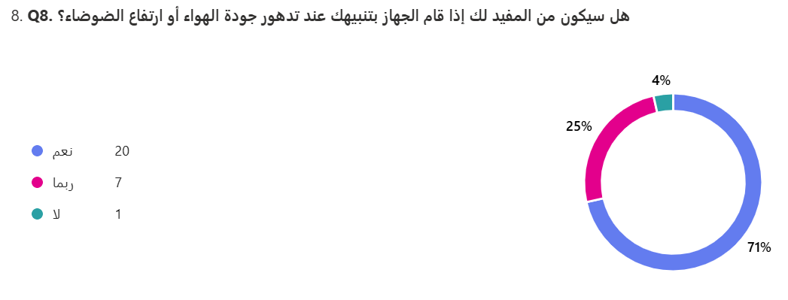
Figure14: Question 8 in the survey
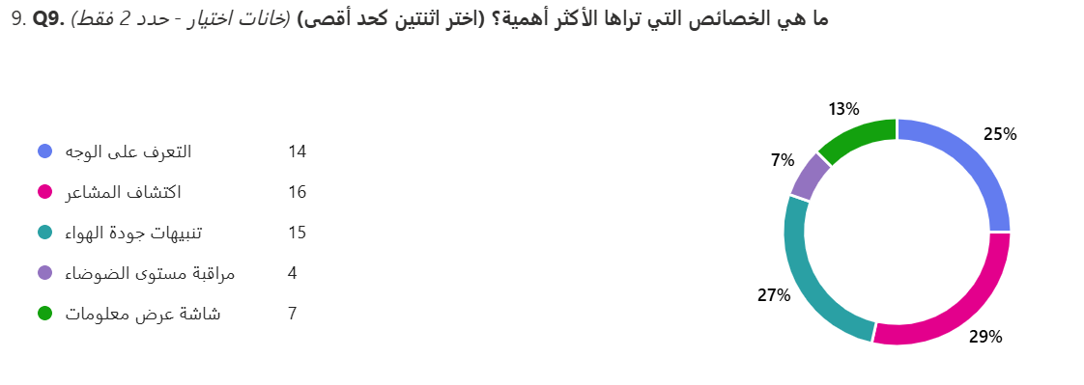 Figure15: Question 9 in the survey

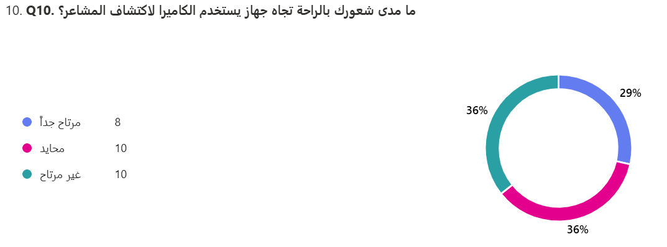 Figure16: Question 10 in the survey
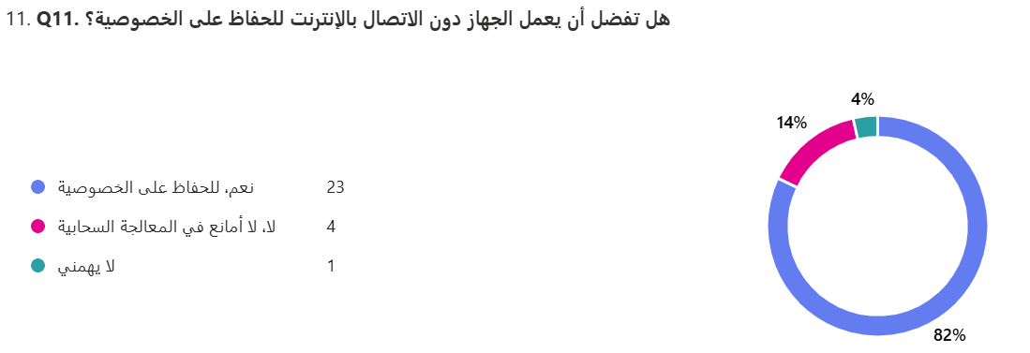 Figure17: Question 11 in the survey

